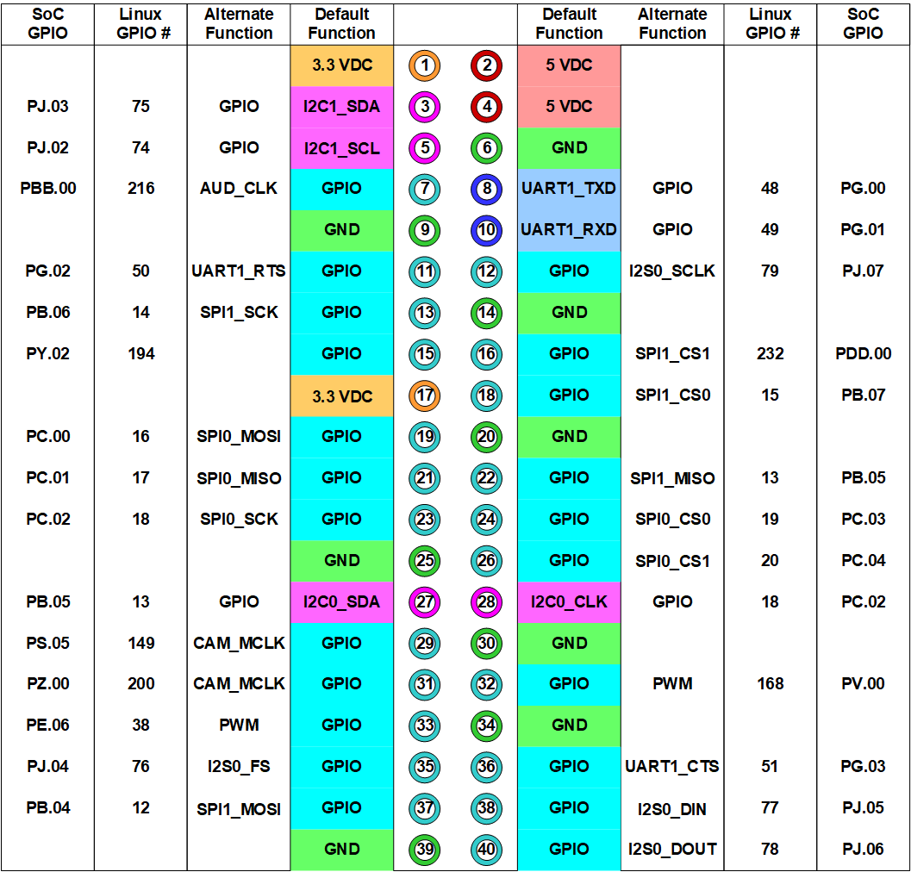

|  |  |  |
| --- | --- | --- |
| **Signal Name** | **Bus Pin** | **Jetson Pin** |
| LED1 | 13 | 19 |
| LED2 | 11 | 21 |
| LED3 | 9 | 23 |
| RBG_R | 17 | 15 |
| RGB_G | 19 | 13 |
| RGB_B | 20 | 11 |
| SW1 | 4 | 35 |
| SW2 | 2 | 33 |
| SW3 | 1 | 31 |
| SW4 | 3 | 29 |

|  |  |  |
| --- | --- | --- |
| **Signal Name** | **Bus Pin** | **Jetson Pin** |
| 5V | 15 | 2, 4 |
| 3.3V | 6 | 1 |
| GND | 5, 7, 8, 10, 12, 14, 16, 18 | 6, 14, 20, 25, 30, 34, 39 |
|  |
|  |
|  |